

PARLIAMENTARY PROCEDURE CONCEPTS

—TEAM EVENT—

NATIONAL 2020

Business Professionals of America is proud to be in partnership with the

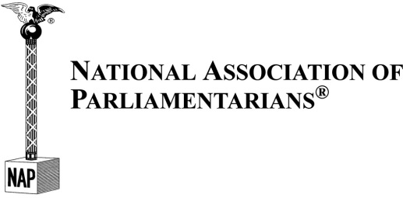

TOTAL POINTS ___________ (100)

Graders: Please double check and verify
all scores and answer keys!

Property of Business Professionals of America.
May be reproduced only for use in the Business Professionals of America
Workplace Skills Assessment Program competition.

Questions are taken from Dunbar’s Manual of Parliamentary Procedure Test Questions (Fourth Edition, 18th Printing) as prescribed by the Workplace Skills Assessment Program guidelines for this event.

 | A |  | B
 | C |  | C
 | C |  | A
 | C |  | C
 | D |  | C
 | D |  | A
 | D |  | D
 | C |  | B
 | A |  | D
 | D |  | C
 | C |  | A
 | B |  | D
 | C |  | B
 | D |  | D
 | C |  | C
 | C |  | D
 | A |  | D
 | C |  | C
 | C |  | D
 | B |  | C
 | A |  | C
 | B |  | C
 | D |  | C
 | B |  | B
 | A |  | B

